Changes document for MS Decom activities

Project: z_i740_aqpl

System : xFE

CD: 151938.

Transport request: DFEK962733

—---------------------------------------------------------------------------------------------------------------------------------

1. Added new buttons for the Google Sheet export functionality.

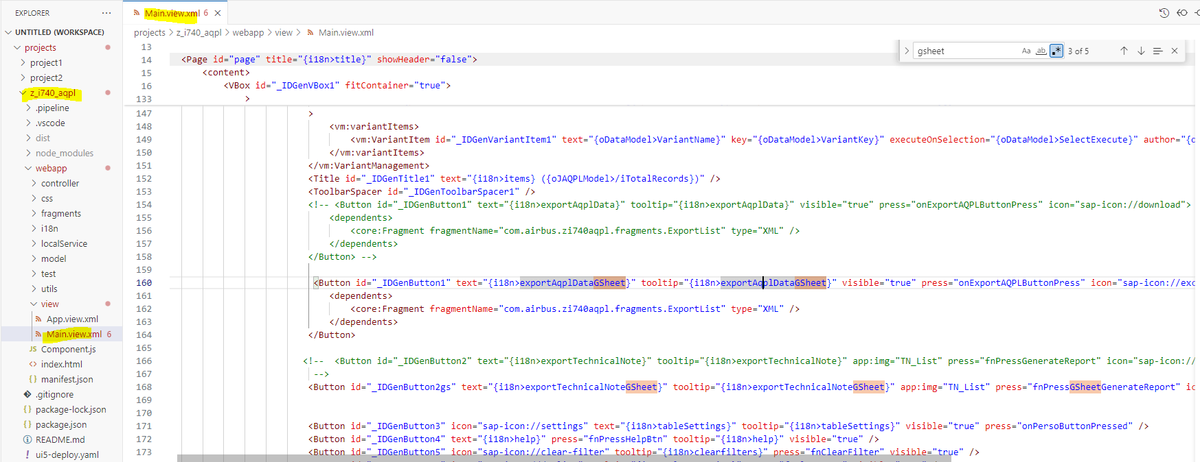

1. Below is the fragment where additional 3 buttons exist.

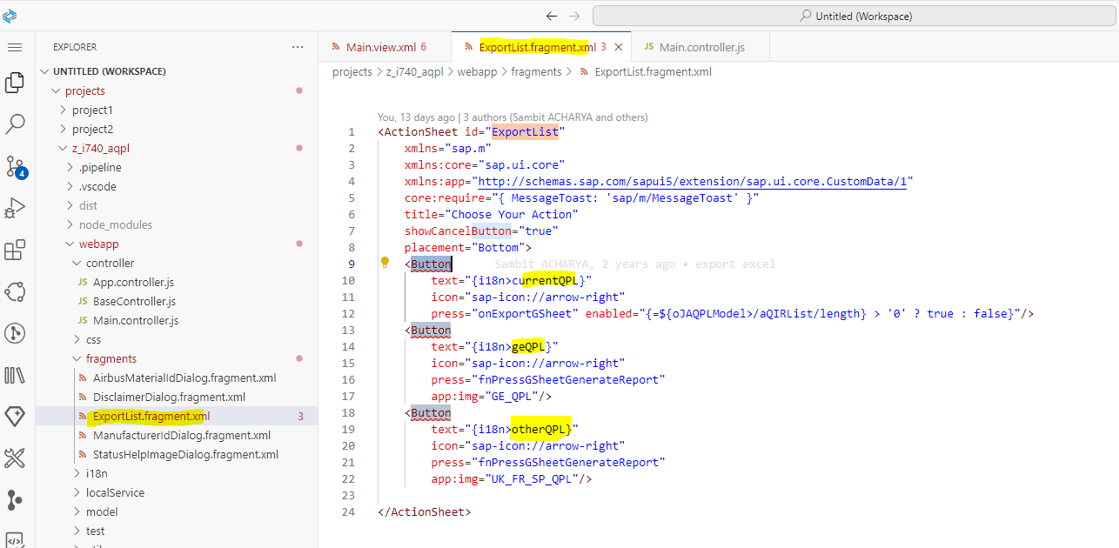

1. Below is the logic to add filters, selections on the dataset and export it in the form of gsheet.

